1. Grade Checker
Take a score as input and print the grade based on the following:
90+ : "A"
80-89 : "B"
70-79 : "C"
60-69 : "D"
Below 60 : "F"
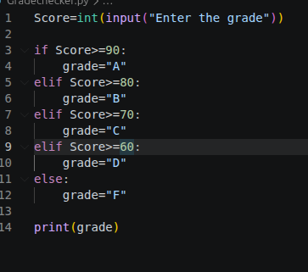
here we used a basic if else statement to carry out marks and all.

Explanation
The program accepts a numerical score from the user and checks the score against predefined grading criteria using an if-elif-else structure.
The conditions are evaluated in descending order to ensure that the highest grade is assigned first. Depending on the score range, the corresponding grade is displayed.

2 Student Grades
Create a dictionary where the keys are student names and the values are their grades. Allow the user to:
Add a new student and grade.
Update an existing student’s grade.
Print all student grades.
A dictionary is used where student names act as keys and their corresponding grades act as values.
The program provides the following functionalities:
- Add a new student and grade.
- Update the grade of an existing student.
- Display all student records.
The program uses conditional statements to check whether a student already exists in the dictionary before adding or updating records. This prevents duplicate entries and ensures accurate updates.
Used dictionary and basic operations. Using if else:
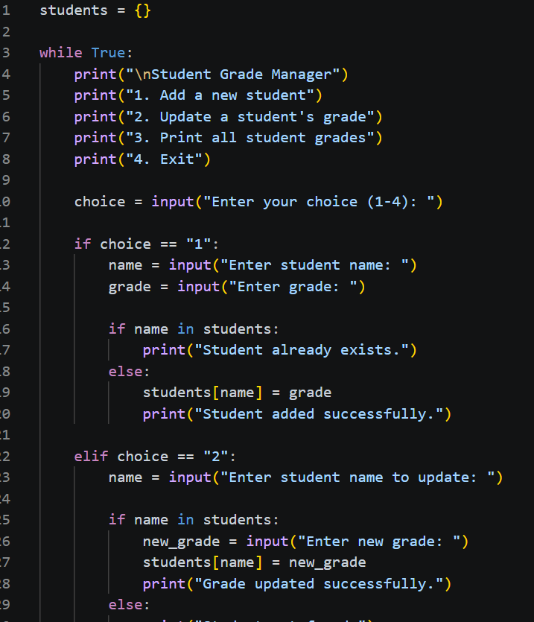
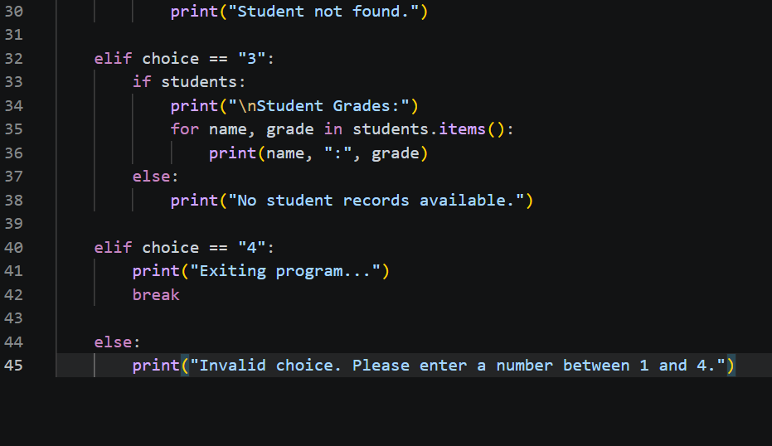
3.Write to a File
Write a program to create a text file and write some content to it.
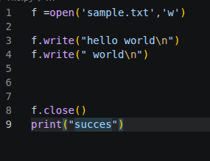
Using file functions like write and open.

Explanation
The program opens a text file in write mode using the open() function. If the specified file does not exist, Python creates it automatically.
The write() function is used to add content to the file. After writing, the file is closed using the close() function to ensure that all changes are saved properly.

4. Read from a File
We used open in read mode and file.read to read and print to display.
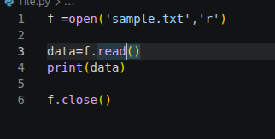

Explanation
The program opens an existing file in read mode using the open() function.
The read() method retrieves the entire content of the file and stores it in a variable. The content is then displayed on the screen using the print() function.
After reading the data, the file is closed to release system resources.

